HawkEye Technology Visualization

Th Bishal Singha | Shubham Raizada
National Institute of Technology, Karnataka  bishalthingom@gmail.com | National Institute of Technology, Karnataka  shbhmrzd@gmail.com

Abstract— HawkEye is one of the most commonly used technologies to assist referees in making correct decisions in sports. Additionally, it has been used to provide interesting statistics while representing the gameplay such that it helps the viewers to understand the game better. In this work an attempt at simulating the Hawk-eye on graphics.h platform is made. The simulation takes in consideration the friction coefficient of the pitch and the inelastic collision between the pitch and the ball and gives decisions on LBW incidents.
Keywords— hawkeye, cricket,friction,collision, graphics, lbw, sports, technology

Introduction
HawkEye is one of the arch technologies acclimated for ball tracking and is used in assorted sports such as cricket, football and tennis. It was developed by engineers at Roke Manor Research Limited in 2001, with the patent being held by Paul Hawkins and David Sherry.
The operation of the technology depends upon image processing to identify the ball in the frames and then conversion of the 2D points captured to form a 3D points in a 3D domain. The existing path of the ball is then projected, followed by the expected path done by interpolation.
The foremost step in hawk-eye is to know the details about the camera used for capturing the ball. This is required as all the cameras used may have different intrinsic features such as the distance from the ball, curvature of the lens and distortion factor. These factors have to be taken care of while processing the images obtained from these. This is known as camera calibration as shown as figure1.
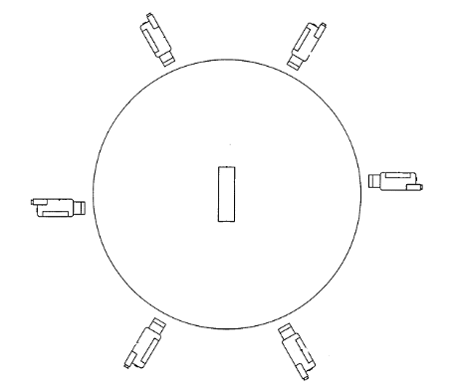
Figure 1: Position of cameras around the field

Once all the details about the camera is known the input video is processed. The prime objective is to identify the ball in the video captured by different cameras. The process involves identifying the pixels of the ball, using techniques of blob detection. Blob detection does not use the color of the ball, as it is not constant throughout the duration of the game and also differs along different formats. The spherical shape of the ball is used for its detection, and given its dimensions other spherical objects such as the helmet worn by the batsman is ignored. Another challenge faced is the identical dimensions of the shadow of the ball, which distort the exact results. Sufficient care is taken for this as the present position of the sun and the apparent shadow characteristics are calculated and taken care of. This is known as ball detection.
After the ball has been detected in the images, the images need to be reconstructed know the 3D position of the ball. Triangulation is the technique used to know the 3D position of the object from several 2D images. The results are obtained by calculating the point of intersection of two vectors in 3D area as shown in figure2.
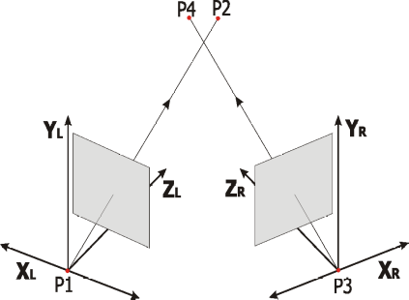
Figure 2: Three-dimensional triangulation of camera rays
However in practical situations, due to noise distortion the vectors seldom intersect. The objective then is to find the least distance between the two non-intersecting vectors. Since the shortest distance vector will be perpendicular to both, the result can be calculated by equating the dot product of the non-intersecting vectors by zero. This is illustrated in figure3.
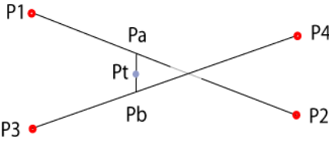
Figure 3: Closest point of intersection for two rays
After the process of triangulation is completed, we'll have points in space that we know represent the position of the ball at specific time instants, also known. A smooth and differentiable curve is computed which passes through most of these points. This curve can be extended to predict the trajectory of the ball.
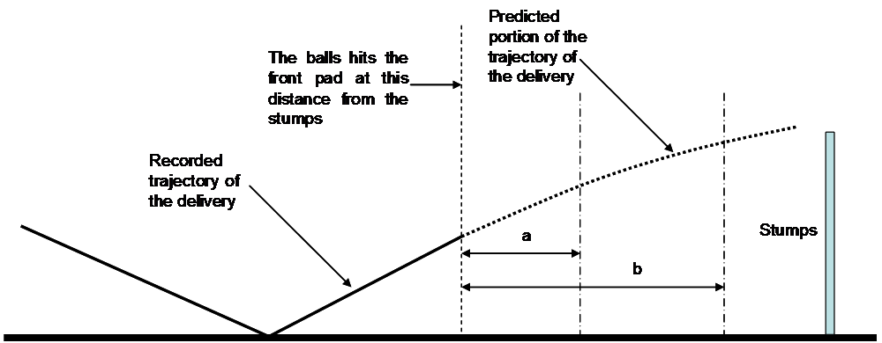Figure 4: Prediction of Ball Trajectory

In this work, we’re going to focus on a visualization of the process of decision making for LBW incidents in Cricket. The work demonstrates the simulation of the entire hawk-eye system based on certain inputs from the user which includes the releasing height of the ball, the pitching distance, the lateral deviation, and the impact distance. The simulation would then show the trajectory of the ball under the proposed conditions.

METHODOLOGY
For our implementation, we’ll be taking as input the release position, release speed, pitching distance, impact distance and lateral deviation. Using these parameters and applying projectile physics and effects of restitution, we’ll be predicting the trajectory of the ball and provide a visualization.
The implementation is carried out in C by including the open graphics library. This provides access to a graphics library that makes it possible to draw lines, rectangles, ovals, arcs, polygons, images, and strings on a graphical window.

Plotting 3D to 2D
The simulation screen has the x-y plan overlapping with it. The z axis is representative of the depth and is assumed to be going into the screen. While plotting the positions of the ball, the 3D position is shown on the 2D screen. This is done by plotting the x and y coordinates of the ball using
x’=x*k;
y’=y*k;
where k is a linear function in z. x’ and y’ are the effective coordinates in the XY plane and x,y and z are the coordinates in the real 3D plane. Constant ‘k’ can be given any value depending upon the ratio taken between the bowler’s end and the keeper’s end of the pitch width. The camera position with respect to which the trajectory is plotted is in line with the bowler, getting a straight view of the ball traversal from the moment of its delivery by the bowler till it reaches the other end. The 3D to 2D conversion can be understood from figure4 where the camera is placed below the structure.

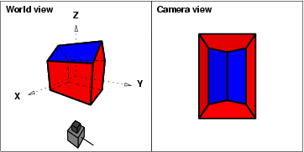
Figure 4: Image creation on a 2D screen

Circlefill Algorithm

While showing the the path of the ball, the ball is shown using white color and the trajectory using cyan. But this causes a challenge since in the immediate sequences of the ball, there is overlap between the present location and the path.If floodfill is used for both the ball and the trajectory, due to the overlapping of the areas the color differentiation was uncertain. A new technique was then used, where the ball was plotted by drawing concentric circles from the center of the ball growing outwards till the radius.

Physics Used
Since we have the release speed and release height, we can predict the path using projectile physics.
Let the release speed be v, release height h and d be the pitching distance, pd be the pitching distance. Then using
t=d/v
h=0.5*(t*t)*a

Once the ball pitches, there would be a drastic change in the velocity of the ball. This is due to the effect of collision between the ground and the pitch, which will in turn change the vertical velocity of the ball.
e=u’/u
Where e is the coefficient of restitution and u is the initial vertical velocity and u’ is the final velocity after collision.
Similarly the horizontal component velocity is changed by the impulse caused by the friction in the short interval of collision. The change in momentum is calculated by using the impulse momentum equation.
F.t=change in momentum

Results and Simulation
Actual hawk-eye simulation uses six cameras so that at least two of them obtain the image of the ball in any circumstance. This is a major factor that increases the cost manifold. Provided accurate data for release speed, pitching distance, impact distance etc. is available this simulation technique can create a visualization close enough to the actual hawk-eye system at a significantly reduced cost.
The simulation discussed above cannot be used in actual sports as there is a lot of noise and uncertainty. Also several factors have to be taken in consideration. But this technique is much cheaper than the actual setup and thus this simulation technique provides a great alternative for objectives of analysis of the pitch conditions or the detail study of a particular bowler. These situations favor the simulation over actual hawk-eye as most of the data pertaining to the pitch such as the coefficient of friction and restitution are already available. Same can be said about the bowlers as they rarely change their bowling action.

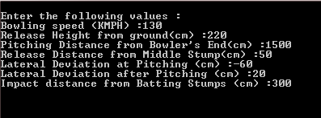
Figure 5: Input Set 1

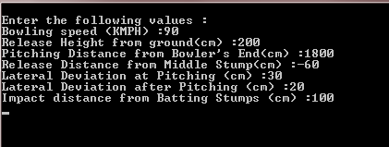
Figure 6: Input Set 2

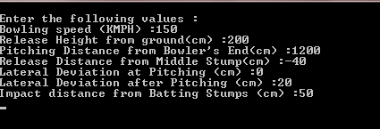Figure 7: Input Set 3
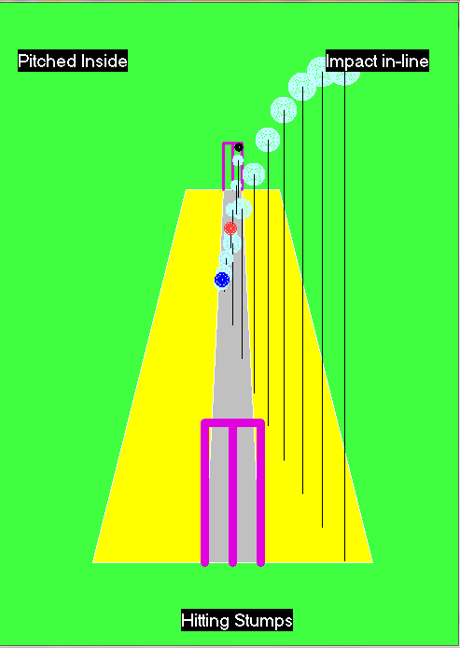
Figure 8: Output for Set 1

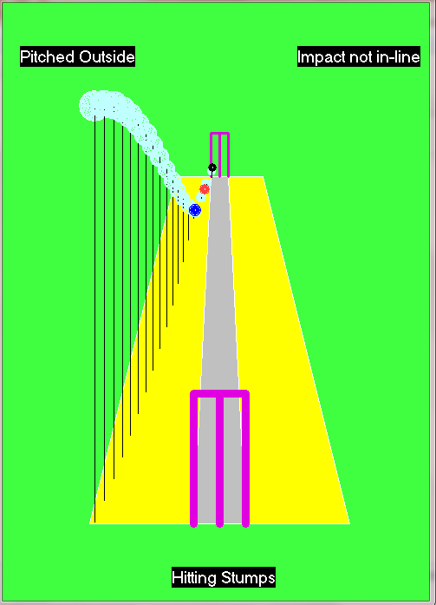
Figure 9: Output for Set 2

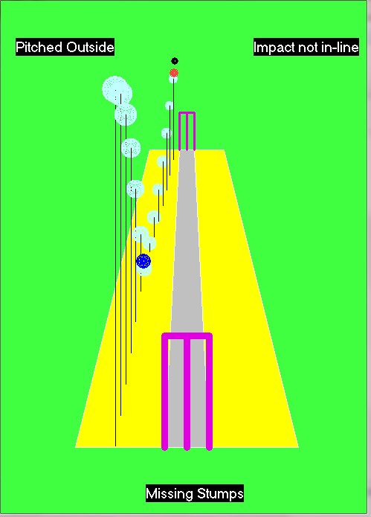
Figure 10: Output for Set 3

COMPARISION WITH EXISTING TECHNOLOGY
In the existing technology six cameras are used to find out the exact position of the ball related to the pitch. Those cameras will capture 2D images with rate of 340 frames per second and later it will be converted to 3D using Triangulation technique. For lbw decision, images from leaving bowler’s hand till hitting the pads will be processed. Total number of images will be approximately 6,000 and processing these many images taken from six cameras will be time consuming and it will take more mathematical calculations in triangulation technique.
In the presented technique, a parameters will be provided as input the release position, release speed, pitching distance, impact distance and lateral deviation. Using these parameters and applying projectile physics and effects of restitution, trajectory of the ball will be predicted and a visualization of the path will be provided. For this two cameras will be required, one each in the xy plane and yz plane. This significantly reduces the number of camera required from 6 to 2, while number of images to be processed is reduced to 3. When we are considering expenditure of installing and maintaining Hawkeye system in cricket, it costs around $60,000 per match. But we have reduced number of cameras to two while reducing the frame rate required, so it will cost around $5,000 per match, which is very less compared to existing technology.
The images are to be captured only at critical points of release of ball, pitching of ball and impact with pads. The camera should respond quickly to these events.

Criteria | Existing Technology | Proposed Technology
Technique | Graph extrapolating | Projectile motion
Camera Type | High Speed | Fast Response
No. of Cameras Required | 6 | 2
Image Capture | Continuous at 300+ fps per camera | At critical points of release, pitching and impact
Cost | $60,000 | $5,000

SCOPE
Due to not having positions of ball at instantaneous periods, this method will slightly compromise on the accuracy of the results but it is negligible compared to the decrease in cost. As this technology is much cheaper compared to existing technology, this can be used at lower levels of cricket and other sports such as tennis and football.
With the advent of HotSpot technology, this can be combined with HotSpot cameras to further reduce the cost.

Conclusion
In this paper we attempted to come with a method to implement the projection of 3D objects in a 2D screen while paying enough stress at all the relative attributes of the object pertaining to its depth and its dimensions. The method places the image in a plane which is parallel to xz plane and the camera has the ability to move. The function thus developed for the projection considers the panning and uses concepts of trigonometry to calculate the revised coordinates. The possibilities of this implementation are numerous. One such attempt was its importance in LBW used in cricket to make correct decisions in case of close calls which might change the course of the match when there is a lot at the stake.

References

- Chao-Chung Cheng, Chung-Te Li, and Liang-Gee Chen, "A 2D-to-3D conversion system using edge information," Consumer Electronics (ICCE), 2010 Digest of Technical Papers International Conference, 9-13 Jan. 2010
- Yu-Lin Chang, Wei-yinchen, Jing-Ying Chang, Yi-Min Tsai, Chia-Lin Lee and Liang-Gee Chen, "Priority depth fusion for the 2D to 3D conversion system," Proc. SPIE, Vol. 6805, 680513 (2008); doi:10.1117/12.766630
- P. Harman , J. Flack , S. Fox and M. Dowley "Rapid 2D to 3D conversion", Proc. SPIE, vol. 4660, 2002
- Q. Wei, "Converting 2D to 3D: A survey," Research Assignment for Master Program Media and Knowledge Engineering of Delft University
- Fisher, J. “A line calling system to improve line umpire performance.” edited by Stuart Miller. International Tennis Federation, 2003.
- P. Lindstrom. Triangulation made easy. In Computer Vision and Pattern Recognition (CVPR), 2010 IEEE Conference on, pages 1554 –1561, june 2010.
- Collins, H.M. Tacit and Explicit Knowledge. Chicago, IL: The University of Chicago Press, 2010.
- McIlroy, P. Hawk-Eye Innovations Ltd., Winchester
- M. Piccardi. Background subtraction techniques: a review. In IEEE SMC 2004 International Conference on Systems, Man and Cybernetics, 2004.
- D. B. Gennery. Visual tracking of known three-dimensional objects. In International Journal of Computer Vision, pages 243–270, 1992.
- Richard Hartley and Andrew Zisserman. Multiple View Geometry in computer vision. Cambridge University Press, 2nd edition, 2003. ISBN =0-521054051-8.
- Collins, H.M. and Pinch, T.J. (1998) The Golem at Large: What You Should Know about Technology. Cambridge and New York: Cambridge University Press.
- Mather, G. (2008) “Perceptual Uncertainty and Line-Call Challenges in Professional Tennis,” Proceedings of the Royal Society B 10.1098/rspb.2008.0211
- X. Yu, H. Leong, C. Xu, and Q. Tian. Trajectory-based ball detection and tracking in broadcast soccervideo. IEEE Transaction on Multimedia, 8(6):1164–1178, 2006.
- McNamee, M. 2010. “Rules, Fairness, And The Apparent Duty To Entertain In Professional Commodified Sport,” Sport, Ethics and Philosophy, vol. 4, no. 3, pp. 235–238, Dec. 2010.
- Cai, W. 2007. “Football, Referee and Law: From the View of the Video Referee and ‘Free Proof’,” Journal of Tianjin University of Sport, vol. 1, no. 1, 2007.

